06/05/2022

**PHYSICAL LAYERS:**

⟹ Lowest layer (layer 1)

⟹ Actual network hardware (Hardware layer; contain cable)

⟹ 2 device directly connected through cable/radiolink will exchange information/message

⟹ Simple LAN = Client computer → Switch → Server

⟹ Step 1: Message to be sent is in bits from client computer

⟹ Step 2: NIC establish network connection, client will request NIC to send a message

⟹ Step 3: NIC translate bits of message into (electrical) signal that goes through network cable

⟹ Step 4: Switch decode signal back to bits and convert it back to signal to sent to Server

⟹ Step 5: Server will receive signal and translate it to bits and convert it to message and send to sender

⟹ Network Hardware includes Network Interface Card (NIC), Network cables

⟹ NIC = Connect device to network (2 types = Wireless & Wired, wired have to be connect to socket while wireless have antenna to receive and send radio signal)

⟹ Network cables (4 Types)

⟹ 1. UTP (most common cable) - Unshielded Twisted Pair

⟹ 2. STP (similar to UTP, except is wrap in metal shielding which protect against electromagnetic interference) - Shielded twisted pair (High internet speed)

⟹ 3. Coaxial cables (outdated, not used anymore)

⟹ 4. Optical fibre (Uses light signals that’s sent through fibre, higher data transfer, it’s not affected by electromagnetic interference at all) - uses in backbone networks (BN), very expensive (not cost effective)

⟹ Signals (2 Types)

⟹ Energy waves travelling through a medium

⟹ Electrical signals (copper cables); Radio waves (Space); Light waves (Optical fibres)

⟹ Analog = continuous signals that changes over a period of time (sine wave)

⟹ Digital = discrete signal carries information in binary form (square wave)

⟹ Digital : sequence of 0s and 1s sent through wave, 0 = no electricity, 1 = electricity

⟹ Encoding types : Unipolar, Bipolar, Manchester

⟹ Unipolar : only 1 polarity, difficult to distinguished 0V and small positive voltage

⟹ Bipolar : 2 polarity (use +ve and -ve to achieve bigger difference in signal)

⟹ Manchester : self-clocking signal

⟹ Analog signal : Amplitude (height of waves), Phase (Direction of waves going at a particular point of time), Frequency (Number of oscillations per seconds)

⟹ Analog can combine amplitude and phase at the same time

⟹ Attenuation = weakening of the signal with increasing distance from the transmitter (cause by obstacles eg. door, wall)

⟹ Modems (Conversion of signals) = Modulation (digital → analog), Demodulation (analog → digital)

**DATA LINK LAYERS:**

⟹ Layer 2

⟹ controlling hardware & error detection

⟹ Media Access Control (MAC) - controls when device can transmit

| Controlled access | 1 device has permission to send at any point of time |
| --- | --- |
| Contention-based access | Access if provided on a first come first served basis (any device and start transmitting at any point of time) |

⟹ If device starts transmitting at the same time, frames sent out will collide and can’t be decoded anymore

⟹ Ethernet (MAC in Ethernet based on CSMA/CD methods:)

| Carrier sense (CS) | Starts a transmission when no other devices is currenting transmitting |
| --- | --- |
| Multiple access (MA) | Multiple devices share the same medium (eg. same cable) |
| Collision detection (CD) | When collision happens:   * Stops transmission of actual frames * Transmit jam signal to notify other devices * Retransmit the frames after random, short amount of time |

⟹

⟹ Disadvantage:

1. Half-duplex, only 1 device can send at a time

2. Network broadcast all messages, all device receive the same message instead of the specific device/address

3. Reliance on collision detection limits the size of the network

⟹ Wireless LAN:

⟹ Advantage:

1. NO cables

2. Flexible network access

3. Enable mobility

⟹ Use radio waves to communicate (frequency regulated)

⟹ 2 main bands WLAN device use → 2.4GHz & 5GHz

⟹ WLAN Topology → Independent …

⟹

⟹ HIGH FREQUENCY ALLOWS MORE INFORMATION TO BE SENT IN THE SAME TIME. WHY DON’T JUST USE HIGHEST POSSIBLE FREQUENCY TO GENERATE? Higher the frequency, the weaker it is when the distance lengthens

13/05/2022

**NETWORK LAYER :**

⟹ Responsible for routing (exchanging packets between different LANs)

⟹ Deliver packets across networks to correct destination

⟹ On the internet, network layer is implemented by Internet Protocol (IP)

⟹ IP Address = send, receive or route message require >= 1 IP address for each of its NIC

⟹ IPv4 (Internet Protocol version 4) addresses (in dotted-decimal notation) = 10101100.00010000.11111110.00000001 (172.16.254.1)

⟹ 10101100.00010000.11111110.00000001 is 32 bits (4 bytes) long where 1 section (eg. 10101100 is 8 bits)

⟹ IPv4 uniquely identifies network interface

⟹ IPv4 hierarchical (similar to postal address)

⟹ identify network (first 16 bits) . identify subnets (8 bits) . Identify host (last 8 bits)

Subnets & LANs :

⟹ Subnets = segmented pieces of a network

⟹ Layer 2 - LAN → Layer 3 - Subnet

⟹ Each subnet corresponds to a single local area network

⟹ Subnet mask /24, if the first first 24 bits is the same for them then they are from the same subnet, if different, it means they are from different subnet from different LAN

⟹ If client A wanna send email to client B from different LAN, message will move to router then to backbone of network and then message will go to router of client B’s LAN and send to client B’s computer

⟹ IPv6 address : 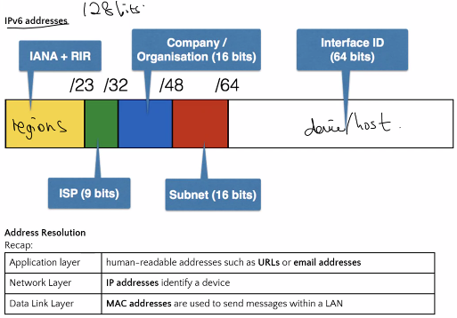

Recap :

⟹ Address resolution? = step that maps from a higher-layer address to a lower-layer address

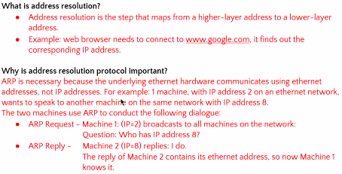

DOMAIN NAME SYSTEM (DNS) :

⟹ 2 types : Iterative & Recursive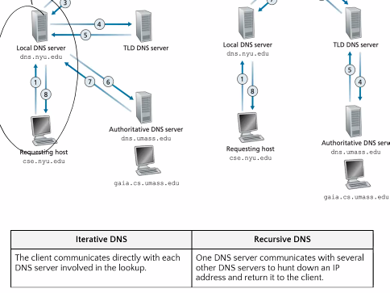

⟹ Routing : true network layer device 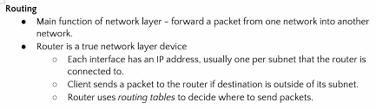

⟹ 2 types of routing : Static & Dynamic 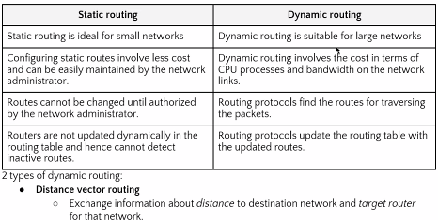

⟹ Distance vector routing judge based on distance 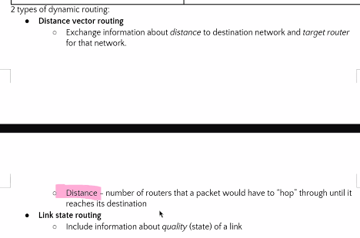

**TRANSPORT LAYER :**

⟹ Transmission control protocol (TCP) : provide a virtual circuit to create the illusion of a reliable point-to-point connection between 2 application; split up application layer message —> short segments; make sure segments arrived correctly & assemble into correct message

⟹ TCP/IP → IP = internet protocol ; TCP = transmission control protocol

⟹ Addressing application : uniquely identifies the connection between the browser window and the web server (130.194.77.37 , 57017 , 216.58.220.99.80)

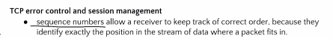

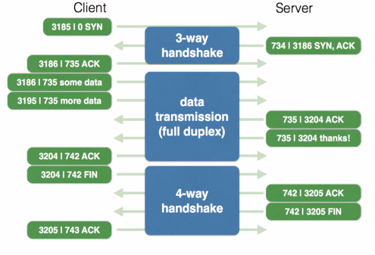

⟹ 3-way handshake = exchange sequence of number to set up connection

⟹ …..(smtg)...... 4-way handshake

⟹ Autonomous system : (BGP is example of distance vector routing)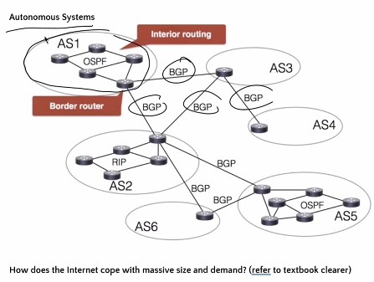

⟹ different autonomous system communicated with each other through border router

⟹ 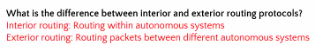

⟹ 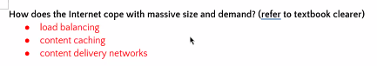

⟹

**Cryptography**

⟹ Plain text → (encryption) → cipher test → (decryption) → plain text

**(need secret keys for decryption)

⟹ Symmetric encryption :

⟹ 



